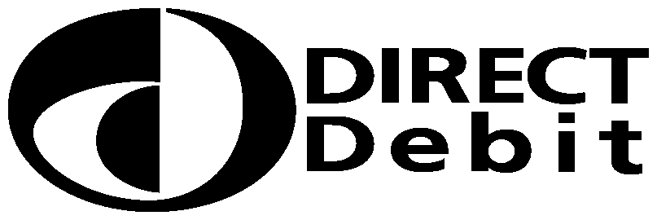
RAYC DD Scheme is open from January to August. Please contact Membership@royalanglesey.org.uk
for further details.
RAYC DD Membership  Please fill in the whole form including official use box  and tick the rate to be applied:  30-60 Yrs …….£180. 60 Yrs & over......£120. 18 – 24….. £55  25 – 29….. £110. Overseas…..£100 Cadet………£30 using a ball point pen. |  |  |  |  |  |  |  |  |  |  |  | Instruction to your  bank or building society  to pay by Direct Debit
 |  |  |  |  |  |  |  |  |  |  |  | Access Smart Debit Service User Number
RAYC Hon. Membership Secretary  6/7 Green Edge  Beaumaris  Anglesey  LL58 8BY |  |  |  |  |  |  |  |  |  |  |  | 2 | 5 | 0 | 9 | 2 | 9
This is not part of the instruction to your Bank or Building Society.
Important – Please complete these details:
Account Holder(s) Name & Address:
Name:
Address:
Postcode:
Email Address:

Name(s) of Account Holder(s)
Bank/Building Society account number
Branch Sort Code |  |  |  |  |  |  |  |  |  |  |  | Instruction to your bank or building society  Please pay Access Smart Debit re RAYC Membership Direct Debits from the account detailed in this Instruction subject to the safeguards assured by the Direct Debit Guarantee. I understand that this Instruction may remain with Smart Debit re RAYC Membership and, if so, details will be passed electronically to my bank/building society.
Name and full postal address of your Bank or Building Society
To: The Manager |  |  |  |  | Bank/Building Society
Address |  |  |  |  |  |  |  |  |  |  |  | Signature(s)
 |  |  |  |  |  | Postcode |  |  |  |  |  | Date
Reference
Banks and Building Societies may not accept Direct Debit Instructions for some types of account
DDI1

This guarantee should be detached and retained by the Payer.

The
Direct Debit
Guarantee
- This Guarantee is offered by all banks and building societies that accept instructions to pay Direct Debits.
- If there are any changes to the amount, date or frequency of your Direct Debit Access Smart Debit re RAYC Membership will notify you 5 working days in advance of your account being debited or as otherwise agreed. If you request Access Smart Debit re RAYC Membership to collect a payment, confirmation of the amount and date will be given to you at the time of the request.
- If an error is made in the payment of your Direct Debit, by Access Smart Debit re RAYC Membership or your bank or building Society, you are entitled to a full and immediate refund of the amount paid from your bank or building society
- If you receive a refund you are not entitled to, you must pay it back when RAYC Membership asks you to
- You can cancel a Direct Debit at any time by simply contacting your bank or building Society. Written confirmation may be required. Please also notify RAYC Membership.
- RAYC is using The ACCESS Group trading as Smart Debit as its agent to collect Direct Debit payments on its behalf. Smart Debit is a Direct Debit bureau with a full infrastructure to operate this process on behalf of the RAYC. If you have any concerns or queries these should be directed to the Honorary Treasurer.

